**📄 Spring Boot Project Setup: spring-learn**

**1. Problem Statement**

Set up a basic Spring Boot project named spring-learn with necessary dependencies, verify the successful execution of the main class, and understand the folder structure, annotation usage, and configuration defined in pom.xml.

**2. Steps**

* A new Spring Boot project was generated on <https://start.spring.io/> using group com.cognizant and artifact ID spring-learn.
* Spring Boot DevTools and Spring Web dependencies were selected.
* The project was downloaded as a .zip file and extracted into the Eclipse workspace root folder.
* The extracted project was built using Maven with proxy configurations via the command line.
* The project was imported into Eclipse through Maven’s “Existing Maven Projects” import option.
* Log statements were added to the main() method in SpringLearnApplication.java to verify the startup.
* The SpringLearnApplication class was executed to ensure Spring Boot was set up correctly.
* The structure of the project was reviewed:
  + src/main/java contained the application’s Java source files.
  + src/main/resources included configuration files like application.properties.
  + src/test/java had unit test files.
* The @SpringBootApplication annotation’s role was discussed — combining @Configuration, @EnableAutoConfiguration, and @ComponentScan.
* The contents of the pom.xml file were reviewed along with its dependency hierarchy.

**Output:**

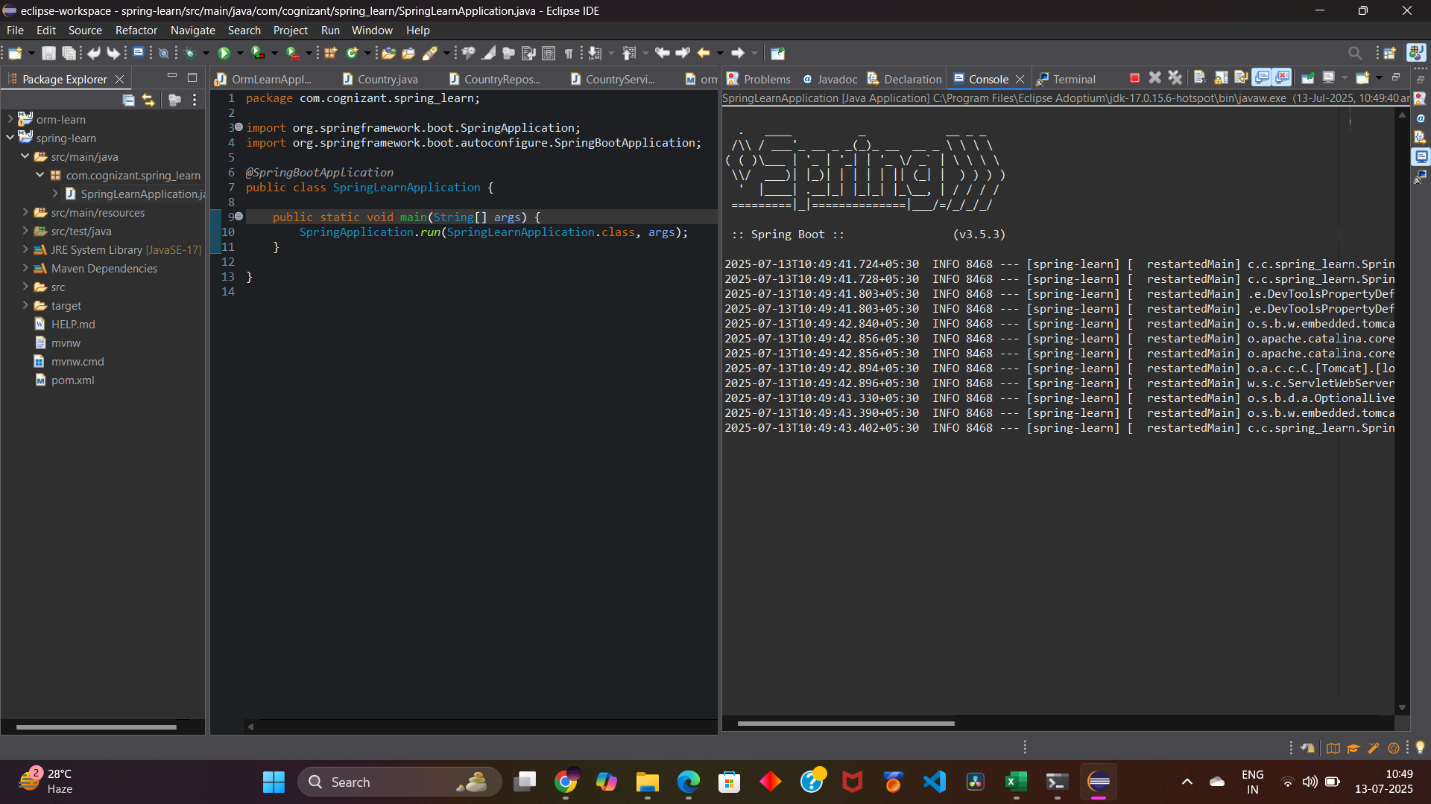

**Hands-on 4: Spring Core – Load Country from Spring Configuration XML**

**✅ Problem Statement**

An airline website needs to allow users to select their country (e.g., US, DE, IN, JP) from a dropdown. Each country is represented by a two-character ISO code and full name. The requirement is to configure this data in a Spring XML file (country.xml) and write a Spring application that reads and displays the configured country object using Spring's XML-based bean configuration.

**✅ Steps**

* A new Spring Boot project was created using Spring Initializr and imported into Eclipse.
* A Country Java class was created under the com.cognizant.springlearn package with fields: code and name.
* Constructor, getter, setter, and toString() methods were added with debug logs inside each.
* A country.xml configuration file was created under src/main/resources to define a bean for a country with ISO code IN and name India.
* The displayCountry() method was implemented in the SpringLearnApplication class.
* This method loaded the Spring application context from the country.xml file and fetched the country bean.
* The method was called from the main() method of SpringLearnApplication.java.
* Logging level was set to DEBUG in application.properties to view all debug outputs clearly.
* The application was executed, and console logs were observed to verify constructor, setter, and getter invocations.

**✅ Output:**

